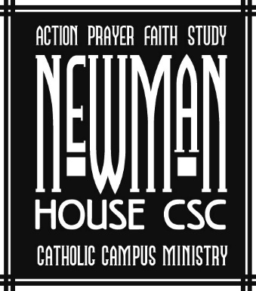
Your Generosity Supports students
at Newman House – Chadron State College

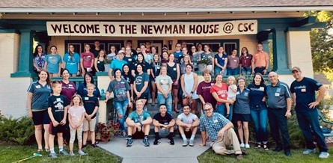
To say that the Newman House here at Chadron State College has positively impacted me would be an understatement. The Newman House has quite literally been a physical, social, mental, emotional, and spiritual safe haven for me along with countless other students. Walking in the front doors of our Newman House, one can sense a spirit of love, joy, peace, hope, and encouragement. Jesus Christ is the heart of this college ministry, and it is evident that the Holy Spirit is working in the transformation of each of our lives! – Caleb Haskell

